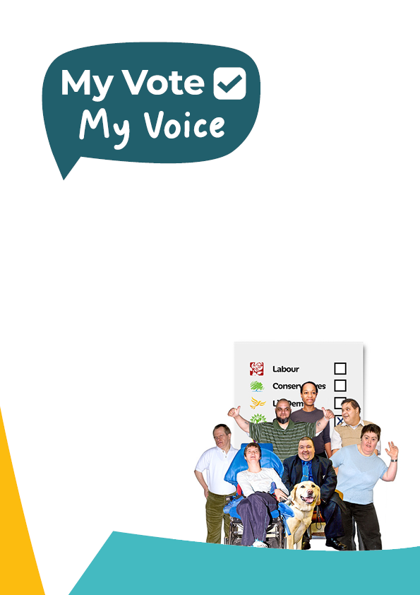

Easy read guide to voting for Autistic patients, patients with learning disabilities and patients with severe mental illness in hospital or in the community under the Mental Health Act.

Contents and pages
 | Topic | Page
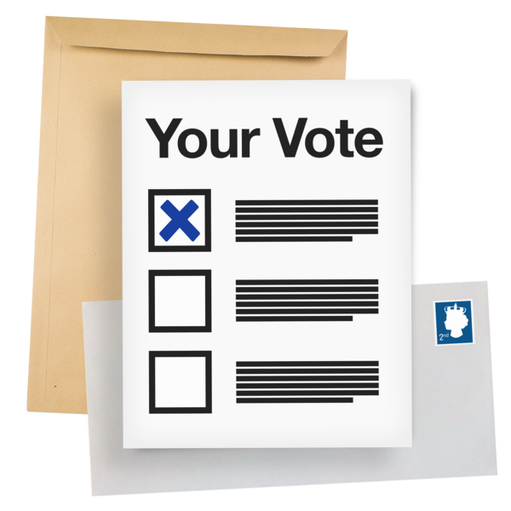 | What is in this guide? | 4
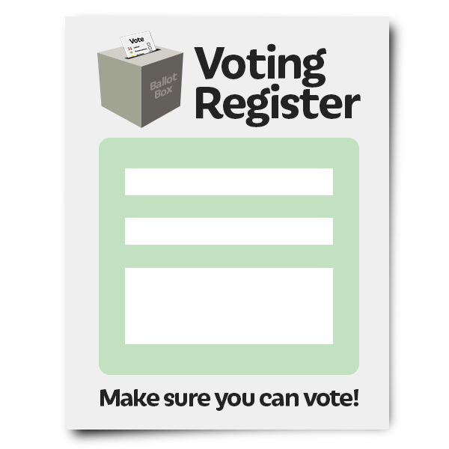 | Who can vote? | 5
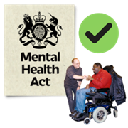 | Voting when you are in hospital or in the community | 7
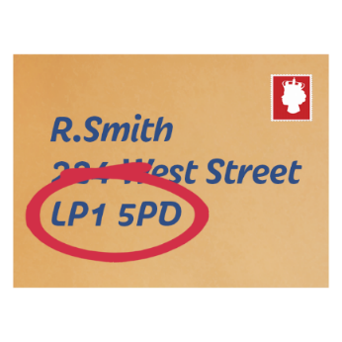 | Registering to vote without a permanent or fixed address | 9
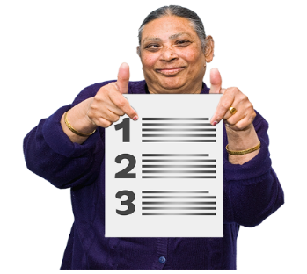 | How to register to vote | 11
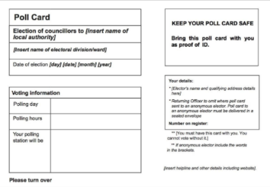 | After registering to vote | 13
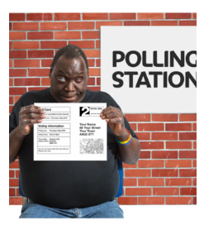 | Ways to vote | 14
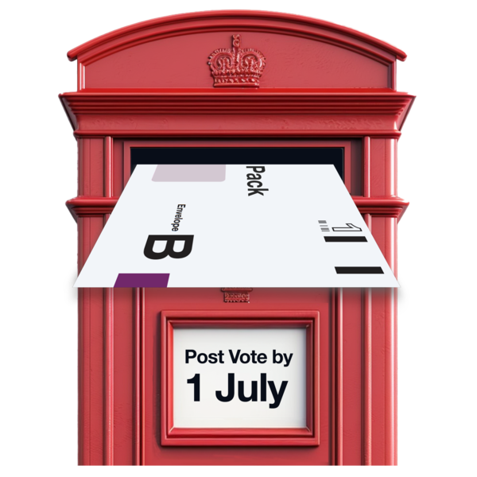 | Voting by post | 18
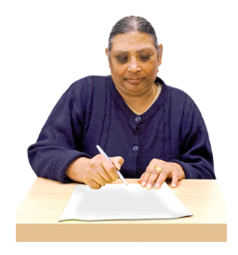 | Voting by proxy | 19
 | Useful links | 21

What is in this guide?

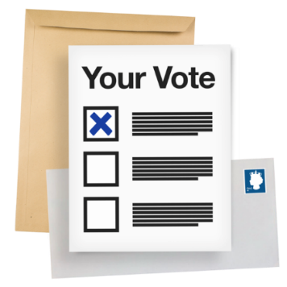 | This guide will tell you how you can vote during a political election.  This guide is for  - Patients having mental health treatment under a Mental Health Act section.  - Patients choosing to have mental health treatment in hospital.
Patients with a mental disorder can find it hard to vote.
Patients with a learning disability or who are Autistic can find it hard to vote.
They might not know everything they need to so they can vote.
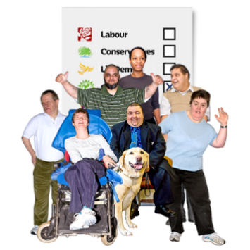 | Everyone who is allowed to vote should get to, if they want.  We have made this guide to help you.

Who can vote?
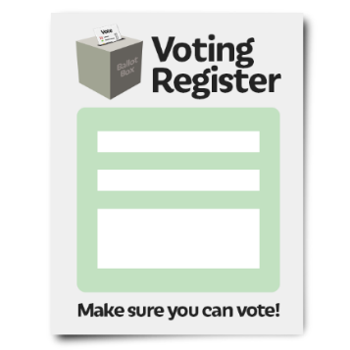 | You can only vote if you are registered to vote.  Registering is when you tell the government that you want to vote.
Not everyone is allowed to vote.
Not everyone is allowed to register.

For example, convicted prisoners are not allowed to vote.
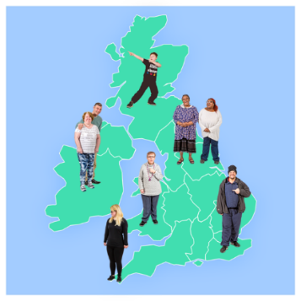 | You can register to vote if you are:  - A UK or Northern Irish citizen  - A commonwealth citizen  - An EU citizen living in the UK
 | You need to be 18 years old or older to vote in a general election.
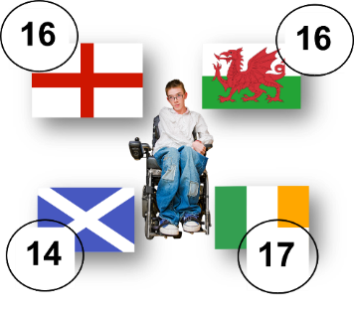 | But you can register when you are younger so you are ready to vote when you are 18:  - In England and Wales you can register when you are 16  - In Norther Ireland you can register when you are 17  - In Scotland you can register when you are 14
You can register to vote even if you aren’t sure who to vote for.

You have time to decide after you register.

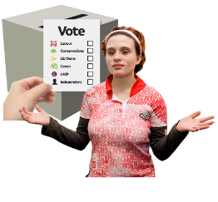  Many | If you aren’t sure if you want to vote at all, that is OK.  Nobody is made to vote in the UK. You can still register to vote and decide not to vote in the end.

Voting when you are in hospital or in the community
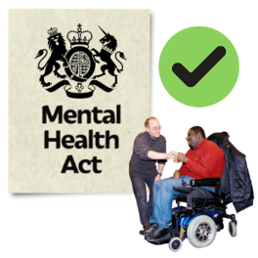 | Most patients on a Mental Health Act section can vote.
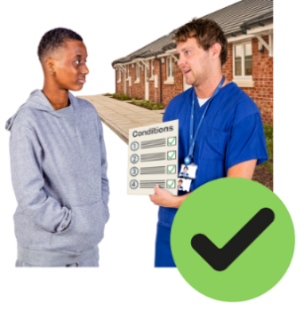 | People living in the community on a Mental Health section 17(A) community treatment order can vote.
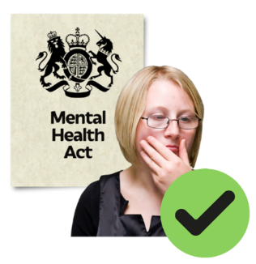 | Voluntary patients wanting mental health hospital treatment can vote.  You can vote whilst in hospital on a  Section 2 for mental health assessment.  Section 3 for mental health treatment.
Some hospital patients involved in crime are detained by the court.
You can vote whilst in hospital on a
Section 35 for medical report.
Section 36 for mental health treatment.
Section 48 moved from prison while on remand
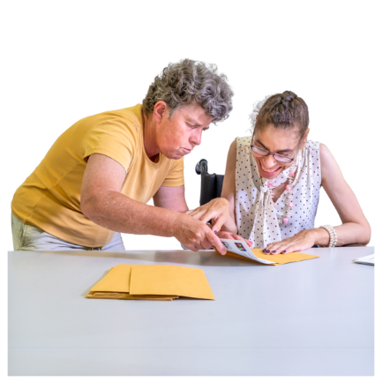 | Some people have trouble understanding, remembering, or making decisions. This can be because they have dementia, learning disabilities, autistic, or mental health issues.  They can vote.  The hospital staff should help them.  Even if you have been told you lack capacity, you can vote.
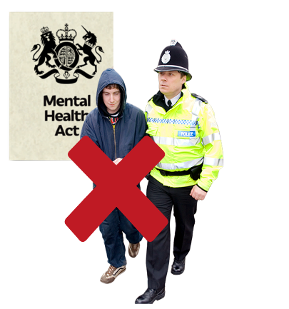 | Some patients convicted of crime are detained in hospital by the court.  You cannot vote on a  section 37 / 38 hospital order  section 45A hospital direction  section 47 prison to hospital move.
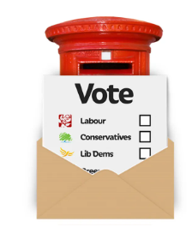 | A voluntary patient and a detained patient on s.17 leave can attend a polling station.  Some patients detained under the Mental Health Act can only vote by post or by proxy.
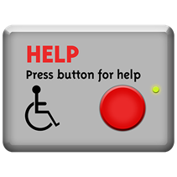 | All patients who can vote should have the support they need to:  Get help with the voting process.  Find and access political parties manifestos/ promises  Contact MP candidates.  Watch and listen to hustings on TV and Radio  Attend hustings online or in-person  Anything else  Ask the staff to help you vote.
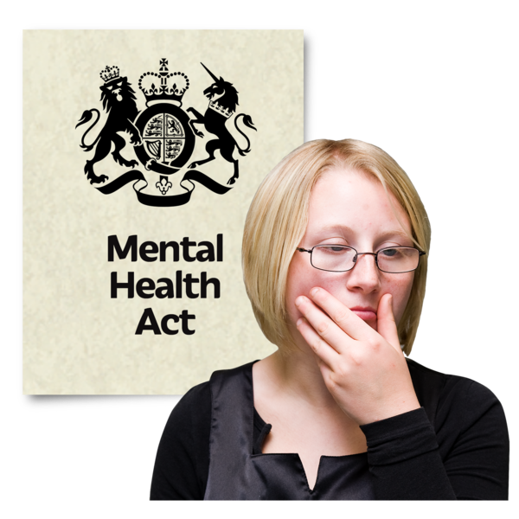 | For more information about your rights click the Mental Health Act - NHS (www.nhs.uk)

Registering to vote without a permanent or fixed address
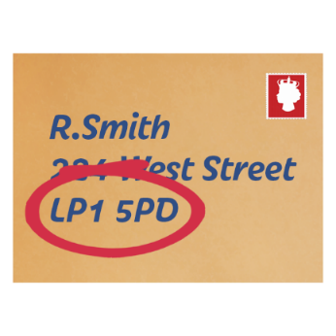 | The register needs to know where people are living to see where they can vote.  People who do not have a permanent or fixed address can still register to vote.
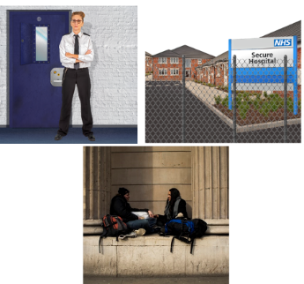 | People might not have a permanent address because:  - They are staying in hospital  - They are homeless  - They are ‘on remand’
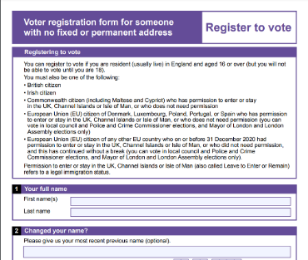 | To register without a permanent or fixed address, you need to make a Declaration of Local Connection.  This tells the register where you are living.
If you are homeless, you can make a Declaration of Local Connection based on where you spend a lot of time.

This could be a friend or family member’s home.

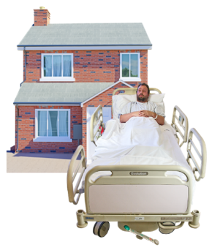 | If you are being treated in a hospital, you can make a Declaration of Local Connection to where you used to live, or where you would be living if you weren't in hospital.
If you need to make a Declaration of Local Connection, click here:
https://www.gov.uk/government/publications/register-to-vote-if-you-havent-got-a-fixed-or-permanent-address

How to register to vote
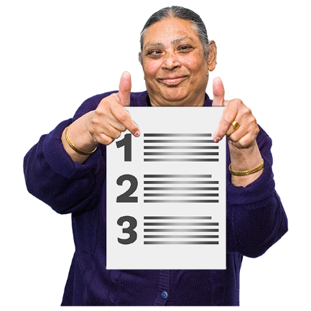 | You can register online at https://www.gov.uk/register-to-vote  This will put your name in a big list of people who are allowed to vote.
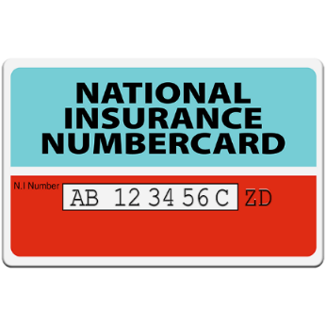 | The easiest way to register is by using your National Insurance Number.  If you cannot find your National Insurance Number, you can still register but it will take a bit longer.
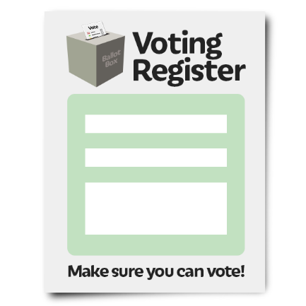 | When you register to vote, your name is added to the Electoral Register.  This is a big list that tells everyone who can vote.
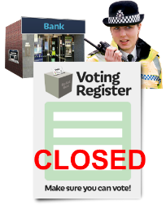  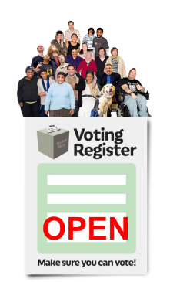 | You can choose to go onto the Open Register or the Closed Register.  Open Register: Anyone can read a copy of the Open Register to see who is registered and where they live.  Closed Register: The only people who can read the Closed Register are the Police and banks.
There is a different way to register so that nobody can find out your name. This is called registering anonymously.
You can do this here: https://www.gov.uk/government/publications/register-to-vote-anonymously

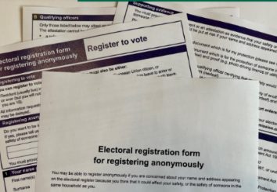 | If you register anonymously, then your name will not be in the Open or Closed Electoral Register.
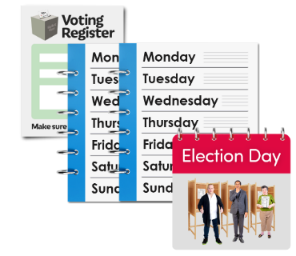 | You must register at least two weeks before Polling Day.  Polling Day is the day everyone votes in the election.
 | If you need help to register, that is OK. Your carer can help you to do it.
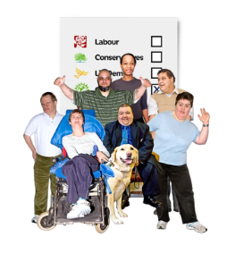 | Remember people with a learning disability and/or autism have the same right to vote as everybody else.

After registering to vote
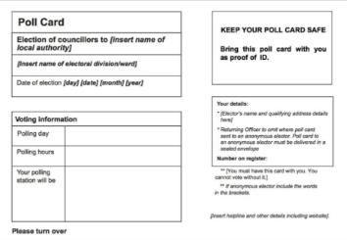 | Everyone who has registered to vote will be sent a polling card through the post.
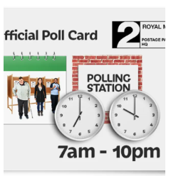 | This card tells you when an election is going to happen
 | The card also says when the last date for voting by post is.
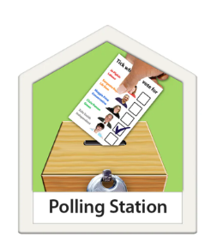 | The card also has the address for where to go if you want to vote in person
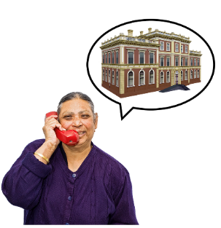 | Sometimes things go wrong and polling cards do not arrive in time.  If that happens, you can call the Electoral Services Department of your local council. They will be able to help you.

Ways to vote
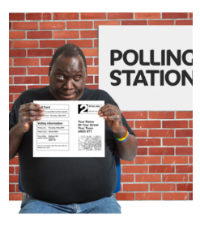 | There are three ways you can vote in an election, these are:  - in person
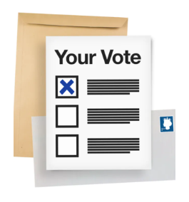 | - by post
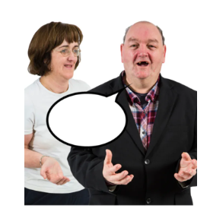 | - or by proxy.  By proxy means that someone else can vote for you.
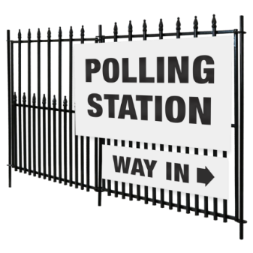 | Most people vote in person.  This means they go to a polling station on polling day.
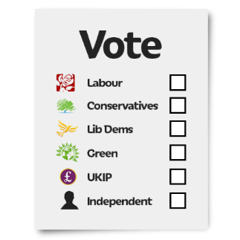 | They vote by marking a ballot that is given to them there.  The ballot lists the names of the candidates, and you mark your choice on it.
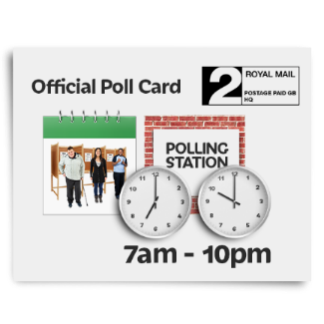 | On polling day, go to the polling station any time between 7 AM and 10 PM.  The address of your polling station will be on your polling card.
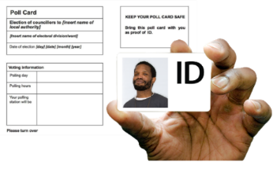 | When you go to the polling station you should bring:  - Your polling card  - Your voter ID
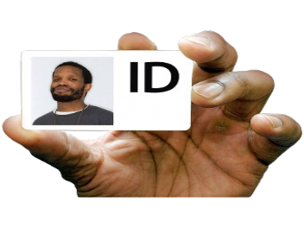 | You will need to show 1 form of ID from this list:  - a UK or Northern Ireland photocard driving licence (full or provisional)  - a driving licence issued by an EU country, Norway, Iceland, Liechtenstein, the Isle of Man or any of the Channel Islands  - a UK passport  - a passport issued by an EU country, Norway, Iceland, Liechtenstein or a Commonwealth country  - a PASS card (National Proof of Age Standards Scheme)  - a Blue Badge  - a biometric residence permit (BRP)  - a Defence Identity Card (MOD form 90)  - a national identity card issued by the EU, Norway, Iceland or Liechtenstein  - a Northern Ireland Electoral Identity Card  - a Voter Authority Certificate  - an Anonymous Elector’s Document
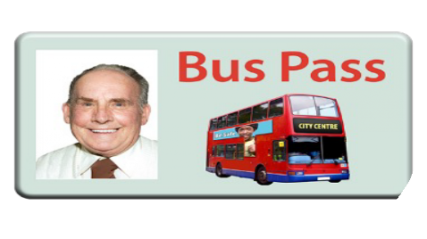 | Some travel cards and some national identity cards are ok to use:  - an older person’s bus pass  - a disabled person’s bus pass  - an Oyster 60+ card  - a Freedom Pass  - a Scottish National Entitlement Card (NEC)  - a 60 and Over Welsh Concessionary Travel Card  - a Disabled Person’s Welsh Concessionary Travel Card  - a Northern Ireland concessionary travel pass
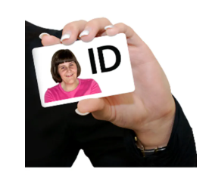 | You will only need to show one type of ID, but it needs to be the original document and not a photocopy or photo of it.  If your photo ID is out of date, it is ok to use it if the photo still looks like you
If you don’t have photo ID you can apply for a Voter Authority Certificate.

You will be able to use your Voter Authority Certificate as photo ID when you vote at a polling station.

A Voter Authority Certificate is free.

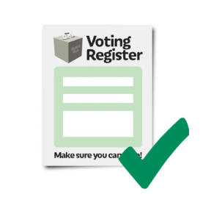 | You need to be registered to vote before you can apply for a Voter Authority Certificate
You can apply for a Voter Authority Certificate online on the Government’s website here: https://www.gov.uk/apply-for-
photo-id-voter-authority-certificate

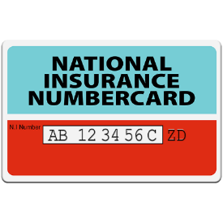  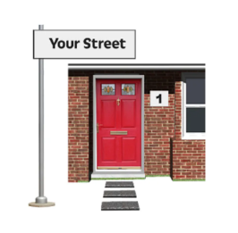  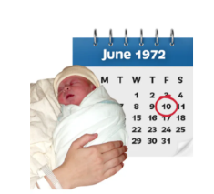  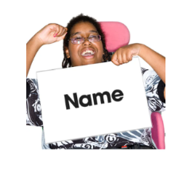 | When you apply for your Voter Authority Certificate, you will need to know your:  - Name  - date of birth  - address  - National Insurance number
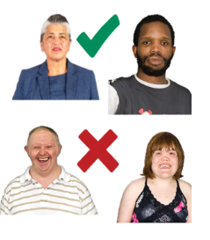 | You will also need to send a passport style photograph with your application. This needs to be a clear photo of your head and shoulders while you are facing forward and not smiling.

Voting by post
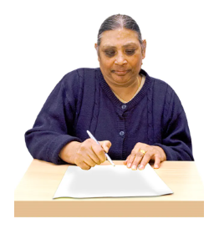 | A postal vote means that you are sent the ballot paper to complete at home and will need to send it to your local council using the pre-paid and addressed envelope they provide.
If you want to vote by post you need to apply at least 2 weeks before polling day.

You can do this online here: https://www.gov.uk/apply-postal-vote
When you ask for a postal vote, you will need:
- photo ID
- your National Insurance number

 | When you get your ballot through the post, you need to fill it and post it back before 10 PM on polling day.
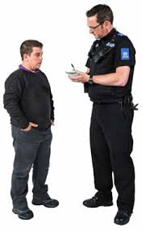 | If someone takes your postal vote from you, or writes on it when you did not want to, talk to the Police.

Voting by proxy
 | Voting by proxy is when someone you trust goes to the polling station and votes for you.
You can ask to vote by proxy online here:
https://www.gov.uk/apply-proxy-vote

 | You have to trust that the person you choose to be your proxy will vote for the candidate you have chosen.
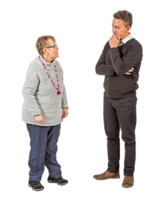 | This person should be someone who cares for your best interests.
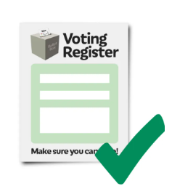 | This person must also be registered to vote and they must be registered to vote in this election you are asking them to be your proxy vote for.
 | This person can visit your polling station or apply for a postal vote in order to vote on your behalf.
 | They must vote for the person or people that you want to vote for.
 | It is important to talk to them about this and make sure they understand.
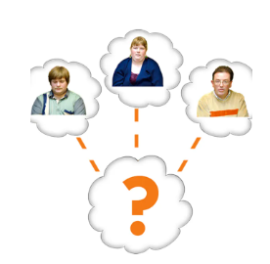 | It is important to think about who you want to vote for and make sure the person who is voting on your behalf understands and knows too.

Useful links

The government's page on how to register to vote is here:

https://www.gov.uk/register-to-vote

The government's page on how to vote is here:

https://www.gov.uk/how-to-vote

How to find your local council is here:
https://www.gov.uk/find-local-council
You can find more Easy Read resources about voting on the My Vote My Voice website https://www.myvotemyvoice.org.uk

